Reference 1

**What is Leave Management? – Employee Leave**

by [Deskera](https://betterbusiness.deskera.com/author/henrik/" \o "Posts by Deskera) | Jul 21, 2016



**What is leave management?** Leave management is one of the simplest yet crucial HR activities that often consumes a significant portion of the HR team’s time. HR personnel have to ensure compliance with leave policies, guarantee the availability of sufficient staff at all times and also make sure that employee satisfaction is retained.

To succeed as an organization, having a reliable [leave management system](https://www.deskera.com/leave-and-attendance-manager/) is important. Research has shown that poor leave management practices may negatively affect employee performance. It can also affect employee morale and therefore impact project deliverables. According to a [research](https://www.roberthalf.com.sg/press/more-leave-days-tops-wish-list-singapore-employees) conducted by Singapore based recruitment firm Robert Half, most employees want more days off. The survey of 500 employees in Singapore found **36 percent** put more annual leave at the top of their wish list, followed by more flexible hours (**32 per cent**) and professional development opportunities (**20 per cent**).

**Employee absenteeism and workforce productivity**

Business leaders often underestimate the impact absenteeism can have on the workforce productivity. Even if they are aware of absenteeism issues, they fail to understand the severity of the situation. According to a [Mercer survey](http://www.mercersignatureevents.com/global_outsourcing_2011/resources/Not%20So%20Hidden%20Cost%20of%20Absences%20-%20FINAL.pdf) participated in by 473 employers:

* The average cost of employee absence is equivalent to 35% of an employee’s salary
* Absences result in 19% of net lost productivity per day
* Indirect costs of absence include: business disruption, overtime, temporary workers, customer dissatisfaction and employee turnover

*“Most businesses still manage staff holiday planning and sickness absence with spreadsheets, but in recent years the cost of managing absence has fallen under the microscope. Businesses assume that staff only takes one or two sick days per year, because they don’t have the tools to run accurate reports. Once they do even a manual report, they are shocked by the results – but they have the data they need to do something about it.”*

***Adrian Lewis, Absence management expert and Commercial Director***

**What is leave management and how to automate it?**

Complex and manually managed leave programs can be costly and may not guarantee an error free process. Therefore, automating leave management proves to be a turnkey solution. Employees have access to [self-service portals](https://www.deskera.com/hrms/employee-self-service/) wherein they can request leaves and access leave benefits. Managers can view and approve leave requests in real time. The system will automatically monitor employee leave requests and evaluate each request against the employee leave balances. The system will also track all outstanding, approved and unapproved employee leave applications and maintain records as required.

This greatly assists in planning resources and evaluating leave impact on already scheduled tasks. Therefore, administrators / managers can make better decisions when it comes to employee leave concerns. Also, an automated leave management system allows employers to enforce leave policies fairly and accurately. Leave application routings and approval flows can also be configured accordingly based on the organization’s business requirements. **Most importantly**, managers can easily access compiled time off information for analysis, reporting and financial estimates.

**Types of employee paid leave**

Organizations offer different kinds of leave, with paid leave being the most common leave type. A survey of 807 organizations, revealed the types of paid leaves that organizations offer to their employees.

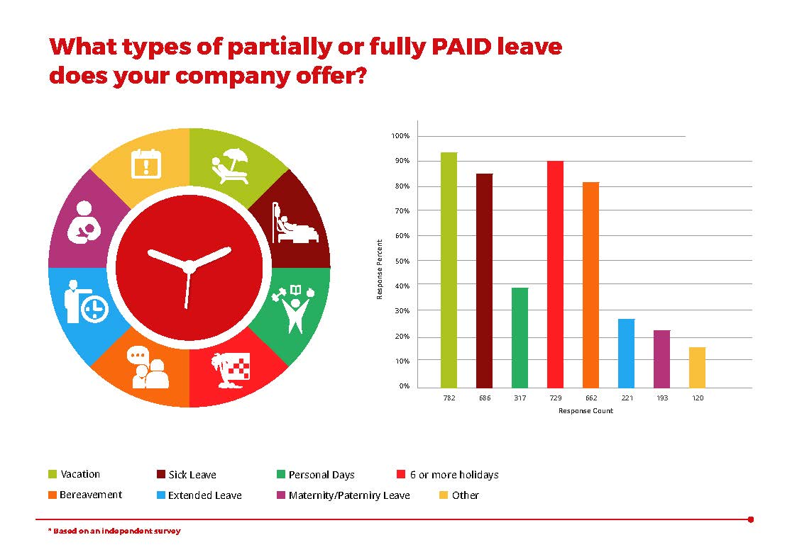

**Benefits of a Leave Management software**

The following are a few significant employee leave management concerns that can be effectively tackled by automating your leave management processes:

* **Excessive Paper Work –**It is quite common to find SMEs as well as large organizations, managing employee leaves across a series of spreadsheets or even using partially paper-based systems. Therefore, accurately tracking and recording employee absenteeism become a real hassle. Automation comes handy in this place by streamlining leave processes. Information related to employee leave is managed in one central repository. Additionally, since all applications and approvals are handled online, dependence on paperwork can be reduced.
* **Legal Compliance –**Organizations always try to manage its employees and remain on the correct side of the law. However, there may be instances where something might go wrong. In cases such as employee’s persistent short term absence, long term illness, retirement, health and safety incidents etc. it is imperative that employee benefit compliances are adhered to. Automating the entire [leave management process](https://www.deskera.com/leave-and-attendance-manager/) allows you to systematically record and store information to support discussions (or in the worst-case scenario a legal condition) and stay on top of key activities via alerts and reminders.
* **Tracking leave pattern –**It is very essential to track employee leave patterns to monitor the amount of paid leave, sick leaves and holiday patterns within your organization. Since there is no chance of manual error due to automation of leave management, analytics for business processes can be accurately studied. The analytics can also be used to map employee performance and diligence.

Automating the leave management process can help facilitate a hassle free and more positive employee-employer work relationship, while also ensuring business productivity is not compromised. Setting up an effective leave automation system allows employees and employers to connect in a way that is more productive and engaging for all parties. Good workforce management practices implemented with HR management software can help your organization accelerate growth.

With a cloud-based leave management system, your team can easily manage paid employee leave, sick leave, medical leave and employee time off. Review your employee leave policies, leave types and annual leave to make your company a more attractive workplace. What is leave management? It can be your competitive advantage in terms of attracting and retaining talent.

Reference 2